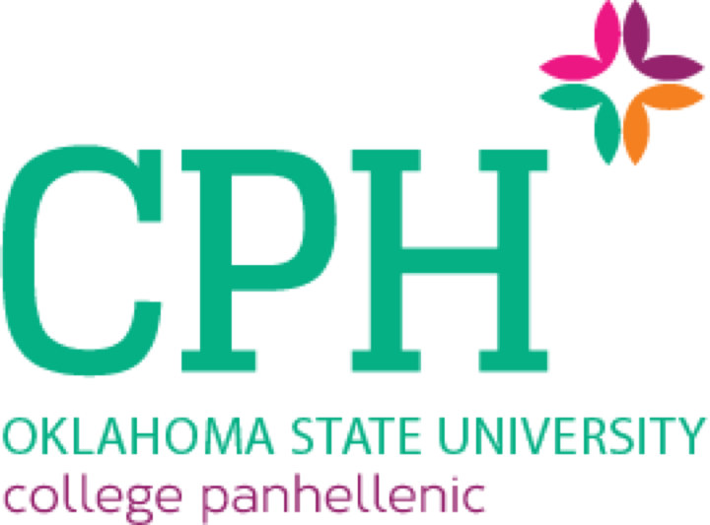

CODE OF ETHICS OF OKLAHOMA STATE UNIVERSITY PANHELLENIC ASSOCIATION
UPDATED FEBRUARY 19TH, 2024

We, the members of sororities at Oklahoma State University, agree to promote honesty, respect, sisterhood and cooperation within the College Panhellenic and our respective chapters and in our daily lives. This code of ethics is designed to inspire our members, reinforce exemplary conduct and values-based leadership and perpetuate lifelong membership to enrich the sorority and Panhellenic experience. All active and inactive sorority members, potential new members, and alumni members of Oklahoma State University shall follow and respect this code of ethics.

We, as College Panhellenic members of Oklahoma State University, agree on and commit to the following:

- As members of the National Panhellenic Conference, the Greek women of Oklahoma State University will respect and obey the Unanimous Agreements set by the National Panhellenic Conference in letter and in spirit.
- As members of the Oklahoma State University Panhellenic Council, we shall respectfully adhere to the bylaws and recruitment rules of the Council.
- All chapters shall abide by all local and federal laws and serve as role models for the University and community. Each woman shall be mindful of the rights of others and dedicate herself to upholding the rights of all groups.
- Provide an equitable and inclusive sorority experience for all women who are interested at the institution.
- Cultivate an environment that encourages and embraces diversity and includes respect for people of all backgrounds.
- No chapter shall discriminate or withhold offers of membership on the basis of race, religion, or culture; acts of discrimination and denying membership on discriminatory premises will not be tolerated.
- Plan recruitment events that provide opportunities for the greatest possible number of women to become sorority members while protecting the rights and privileges of individuals and chapters.
- Be respectful of the rights of every potential new member to make a personal choice, including but not limited to: not joining the sorority community at a specific time, intentional single preference or preference all sorority chapters.

- No chapter shall require members to attend events that fall on religious or cultural holidays.
- All chapters shall meet financial obligations in a timely manner.
- It is in accordance with the dignity and good manners of Greek women:
  - To avoid disparaging remarks about any Greek or non-Greek organization or any potential new member;
  - To create friendly relations between Greek and non-Greek women;
  - To avoid publicity on Panhellenic matters which are not the concern of non-members in the University and community.
- During sporting events and other competitive activities between chapters (e.g.—Homecoming, Freshman Follies, etc.) all Greek women as participants or as fans will abide by the rules and maintain good sportsmanship.
- All Greek issues stated as confidential must remain as such.
- Hazing as defined by Oklahoma State University and each chapters’ national policies will not be tolerated.
  - All chapters and members are encouraged to report hazing if they are aware of such.
- All acts of vandalism or pranks, whether personal or against a chapter will be strictly prohibited. This includes but is not limited to: toilet papering chapters, shoe polishing cars, removing Greek letters or paraphernalia from chapter houses, etc. *Chalking and shoe polishing may be permitted if and only if permission is received from the chapter president with knowledge and consent of the House Director.*
- All chapters and their members shall be encouraged to support all Panhellenic service and philanthropic events.
- The Oklahoma State Panhellenic Council discourages Panhellenic chapters from participating in or sponsoring brother/sister auxiliary groups in accordance with the NPC Manual of Information Article X Section 2.

We, as College Panhellenic members of Oklahoma State University, agree and commit to hold one another accountable to this code of ethics, remembering at all times that we represent not only our individual chapters but also the Panhellenic community as a whole. These are the tenets by which we strive to live.

Infringement of this Code of Ethics should be reported to the Panhellenic Vice President Judicial Affairs, Panhellenic President, or the College Panhellenic Advisor within 24 hours or on the first school day after the alleged infringement is known and no more than thirty school days after it has occurred. Reported violation of any code will follow the Oklahoma State Panhellenic Association Judicial Process as outlined in the Oklahoma State Panhellenic Association’s bylaws.

